English Language:
GCSE to A Level Transition
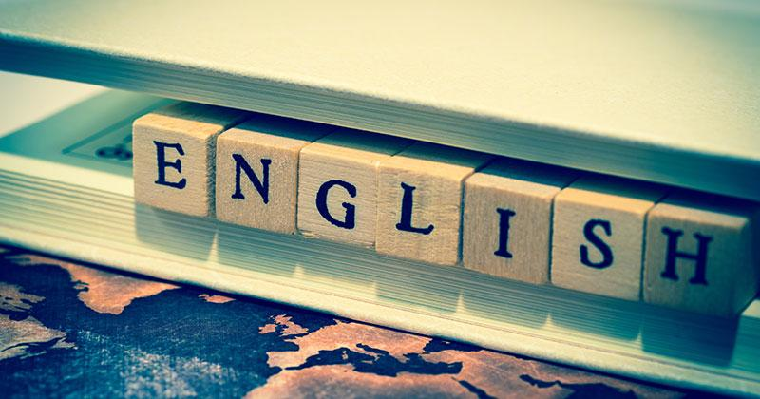

Thank you for considering A Level English as one of your options. Please remember that English Language at A Level is very different from English Language at GCSE.

Inside this booklet, you will find a variety of tasks to complete. Please submit your work to Mrs Bates-Bryan in your first A Level lesson in September.

Activity 1: Terminology
Learning and using core terminology is fundamental when it comes to studying Language at A Level. Complete the grid below to help learn some new vocabulary.
Terminology | Definition | Example
Antonym

Dialect

Hypernym

Hyponym

Idiolect

Idiom

Neologism

Noun phrase

Possessive pronouns

Activity 2: Nouns
Nouns are the names of objects, feelings, people, places and states of being. Nouns are the largest word class in the English Language.
Look at the sentences below and underline the nouns. Write how many nouns you have identified.
Sentence | How many nouns?
The cat sat on the mat.
In 2019, Cats received the Rotten Tomato Worst Film Award.
The dog sat on the rug and howled for his dinner.
His name was John.
Do you prefer pizza or pasta?
The sun is shining brightly in Morecambe.
The antique clock with the silver face is hung in the hallway.
Although New York is widely visited, Washington DC is America’s capital.
It rained cats and dogs yesterday.
The beach with the golden sand and palm trees stretched for miles.

Nouns can be further categorised:

Fill in the table, showing you understand the types of nouns.
Type of noun | Function | Example
Common | The name of a person, organisation or group beginning with a capital letter.
Abstract
Concrete
Group

Being able to identify word classes is the first step in analysis at A Level. You next need to begin to understand their use and effect. In order to do this, you will need to consider contextual factors also.
Look at the text below. It is a 20th century advert for rice.
- Underline all of the nouns in the text.
- Pick five nouns and explore the writer’s purpose in including these nouns.
- Write a short commentary, analysing the use of these nouns, their importance and any contextual factors you can think of. (There is a WAGOLL to help you)
WAGOLL:
As expected, there is the repetition of the common noun “rice”. The purpose of this is to advertise the product to potential buyers. The use of the proper noun “Comet rice” is interesting and helps to sell the product. “Comets” have connotations of speed and space travel. This is effective as the producers may be trying to convey that their product is out of this world and quick to cook. In terms of positionings, comets are in the sky, therefore the writer could be suggesting their rice is of a heightened quality than their competitors.

Activity 3: Accents and Dialects
Complete the following questions about accents:
- Do you have an accent?
- If you answered yes, what is your accent? If you answered no, why do you think you haven’t got an accent?
- Do you have a favourite UK accent?
- Do you have a least favourite accent?
- What would you say it is about these accents which make you like or dislike them?
- How effective are you at identifying a speaker’s accent? 1 = poor, 5 = good. Why do you think this is?
Listen to ten speakers from the UK. These can be real-life people or people you see and hear on television. Try to consider a variety of speakers (eg. different ages, genders and regions). Complete the table below:
 | Where do you think the speaker is from? (region, city or town) | Do you like the accent? | What is your impression of the accent? (educated, trustworthy, friendly, etc)
1
2
3
4
5
6
7
8
9
10
Activity 4: Language and Social Class
In spoken language, it is often possible to gain insight into someone’s social class by studying their language. Most speakers of English use the following features in their speech:
Overt prestige | This is the use of Standard English; it is generally socially acknowledged as 'correct' and therefore valued highly among all speakers of the language, meaning the speaker has overt prestige in society.

Covert prestige | Some people use forms of language which receives respect or recognition from groups in society. The use of non-standard words and phrases is often associated with “cool” speech or slang and the speaker gets covert prestige from using this anti-establishment style of speech.

Solidarity | Some people use language to form bonds with others. They also might copy or imitate a speaker if they hold them in a position of authority or respect. Using language in this way creates solidarity.

Exclusion | In the opposite way, some people use language in a way which excludes others from their discussion. This could be through using words and phrases they know won’t be fully understood or by introducing topics which others won’t or can’t join in with. This is known as exclusion.

Watch a clip from a television programme which represents people or characters who are traditionally “lower class”. Examples might be The Only Way is Essex, Geordie Shore, Only Fools and Horses, Coronation Street, Eastenders, The Royle Family, etc. Listen to the speakers and identify:
- Which language features do the speakers have in common? (eg swear words, slang words, etc)
- What examples of Standard English do you hear?
- What examples of non-Standard English do the speakers use?
- Which of the above four concepts can you identify being used amongst the speakers?

Activity 5: Language and Gender
It is widely accepted amongst linguists that males and females use language differently.
Fill in the grid below with as many stereotypes as possible. Consider clothes, hobbies, interests, behaviour and anything else you can think of.
Males | Females
Blue  Football | Pink  Netball

Gender | The fact society and culture defines how men/women are supposed to be, feel and behave.

Sex | The physical and biological differences between men and women.

Read the below binary statements. Decide to what extent you agree with each statement. What evidence do you have to support your ideas?

- Boys and girls are brought up differently in 21st Century Britain.
- Women gossip more than men.
- Girls are better at English than boys.
- English is a sexist language.
- Women are better at being sociable and getting on with people.

Look at the words in the table below. What do you notice about the connotations?

Male term | Female term | What do you notice?
Master | Mistress | A master conveys power and suggests authority and ownership. It is a respected position. A mistress is unequal because it traditionally refers to a woman who has an extra-marital affair with a man.
Lord | Lady
Wizard | Witch
Batchelor | Spinster
Guys | Girls

Mini investigation: you are going to conduct some research. This could be into toy adverts, children’s clothing, food, etc. Once you have decided on your area of research, you are going to gather examples of data. This could be pictures from magazines, screenshots from the internet, cut outs from newspapers, leaflets which are delivered to your house, and so on.

Collect your examples (this is called data) and consider whether you can find any examples of how the texts are designed for specific genders. Then you are going to write a summary of 400-500 words, explaining what you have found.

There is a WAGOLL below for you to consider.

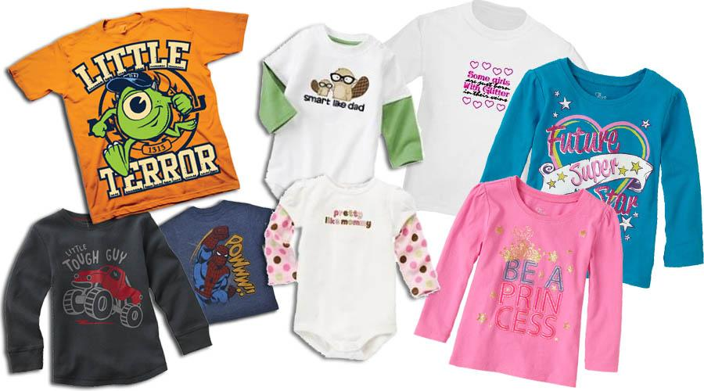

Boys’ t-shirts | Girls’ t-shirts
“Little Terror”  “Little Tough Guy”  “Powww!!”  “Smart like dad” | “Some girls are just born with glitter in their veins”  “Future super star”  “Be a princess”  “Pretty like mummy”

These t-shirts promote inequality and sexism within society and teach potentially damaging lessons to young people. “Little Terror” appears to condone poor behaviour from little boys and this could send subliminal messages to young people growing up: why is one gender expected to behave while the other gender is allowed to be a “terror”?

The t-shirts also enforce the stereotype that little boys like cars and superheroes. Whilst this is undoubtedly true for some males, it excludes young females and teaches them that there are such things as “boys this” and “girls that”. This can also place unnecessary pressure on young people by enforcing the message that they are only allowed to play with certain toys or watch programmes on television about specific topics.

Alternatively, when considering the girls’ t-shirts, you notice a very different message being conveyed: “Some girls are just born with glitter in their veins” suggests girls are overly concerned with the appearance of things and represents females as being focussed on aesthetics. This is reinforced by the “Pretty like mummy” slogan which implies girls should focus on their levels of attractiveness if they want to succeed in life and be happy. The binary message is “Smart like daddy”, suggesting girls shouldn’t worry about their educational achievement because their sole purpose is to marry and become a “princess”.
Activity 6: Original Writing

Discourse features are in all written and spoken texts. A discourse feature is essentially a language feature that you would expect to find in a text. For example, spoken discourse features could be pauses, non-standard pronunciation of words (goin’ rather than going) and fillers such as um or err.
A holiday brochure, on the other hand, may include the following discourse features: the use of the second person pronoun you to address the reader directly, superlative adjectives like best or most, and bullet pointed lists of selling points the holiday offers.

What discourse features would you expect children’s stories to include? List as many as you can.

Now read the below version of Little Red Riding Hood. It is a modernised, politically correct version which means it tries to eliminate all examples of inequality. As you read, consider how the fairytale is different from the original.
There once was a young person named Red Riding Hood who lived with her mother on the edge of a large wood. One day her mother asked her to take a basket of fresh fruit and mineral water to her grandmother's house--not because this was womyn's work, mind you, but because the deed was generous and helped engender a feeling of community. Furthermore, her grandmother was not sick, but rather was in full physical and mental health and was fully capable of taking care of herself as a mature adult.
So Red Riding Hood set off with her basket through the woods. Many people believed that the forest was a foreboding and dangerous place and never set foot in it. Red Riding Hood, however, was confident enough in her own budding sexuality that such obvious Freudian imagery did not intimidate her.
On the way to Grandma's house, Red Riding Hood was accosted by a wolf. who asked her what was in her basket. She replied, "Some healthful snacks for my grandmother, who is certainly capable of taking care of herself as a mature adult."
The wolf said, "You know, my dear, it isn't safe for a little girl to walk through these woods alone."
Red Riding Hood said, "I find your sexist remark offensive in the extreme, but I will ignore it because of your traditional status as an outcast from society, the stress of which has caused you to develop your own, entirely valid, worldview. Now, if you'll excuse me, I must be on my way."
Red Riding Hood walked on along the main path. But, because his status outside society had freed him from slavish adherence to linear, Western-style thought, the wolf knew a quicker route to Grandma's house. He burst into the house and ate Grandma, an entirely valid course of action for a carnivore such as himself. Then, unhampered by rigid, traditionalist notions of what was masculine or feminine, he put on Grandma's nightclothes and crawled into bed.
Red Riding Hood entered the cottage and said, "Grandma, I have brought you some fatfree, sodium-free snacks to salute you in your role of a wise and nurturing matriarch."
From the bed, the wolf said softly, "Come closer, child, so that I might see you."
Red Riding Hood said, "Oh, I forgot you are as optically challenged as a bat. Grandma, what big eyes you have!"
"They have seen much, and forgiven much, my dear."
"Grandma, what a big nose you have, only relatively, of course, and certainly attractive in its own way."
"It has smelled much, and forgiven much, my dear."
"Grandma, what big teeth you have!"
The wolf said, "I am happy with who I am and what I am," and leaped out of bed. He grabbed Red Riding Hood in his claws, intent on devouring her. Red Riding Hood screamed, not out of alarm at the wolf's apparent tendency toward crossdressing, but because of his willful invasion of her personal space.
Her screams were heard by a passing woodchopperperson (or log-fuel technician, as he preferred to be called). When he burst into the cottage, he saw the melee and tried to intervene. But as he raised his ax, Red Riding Hood and the wolf both stopped.
"And just what do you think you're doing?" asked Red Riding Hood.
The woodchopper-person blinked and tried to answer, but no words came to him.
"Bursting in here like a Neanderthal, trusting your weapon to do your thinking for you!" she exclaimed. "Sexist! Speciesist! How dare you assume that womyn and wolves can't solve their own problems without a man's help!"
When she heard Red Riding Hood's impassioned speech, Grandma jumped out of the wolf's mouth, seized the woodchopperperson's ax, and cut his head off. After this ordeal, Red Riding Hood, Grandma, and the wolf felt a certain commonality of purpose. They decided to set up an alternative household based on mutual respect and cooperation, and they lived together in the woods happily ever after.

Now complete the table of discourse features based on the politically correct version of Little Red Riding Hood. The first two have been done for you.
Discourse Feature | Example | How is this politically Correct?
Strong characters | “fully capable of taking care of herself” | Usually, females in fairytales are either evil and try to kill people or are in need of rescue.
Humour | "It has smelled much, and forgiven much, my dear." | The idea of forgiving unpleasant smells is humorous because it is a reference to other people’s flatulence.

You are now ready to rewrite your own fairytale in a politically correct way. Choose and read an existing fairytale. Then rewrite it in a modern way, ensuring you include discourse features and politically correct language and ideas.

