BTEC Level 3 in Health and Social Care Transition Booklet
A Level Geography
Transition Booklet 2021

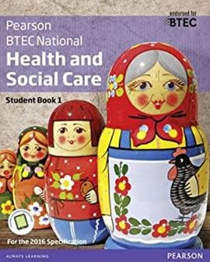
This pack contains information about Level 3 Health and Social Care and a programme of activities and resources to prepare you to start the course in September. Please use this during the summer term and the summer holidays to prepare for your BTEC course.

Please note the compulsory summer work which starts on page 3
About the course: The specification we teach is produced by Pearson and is a BTEC National and a full copy of this specification and other useful information is available at:
https://qualifications.pearson.com/en/qualifications/btec-nationals/health-and-social-care- 2016.html

The course consists of the following Units:

In Year 12:
The units for the single award will be:
Unit 1- Human Lifespan Development
Unit 5- Meeting Individual Care and Support Needs

In Year 13:
The units for the single award will be:
Unit 2- Working in Health and Social Care
Unit 14- Physiological Disorders and their Care

Assessment:
Assessment takes the form of examinations that last 1 hour and 30 minutes as well as internally assessed assignments that will be provided by your teacher using the exam boards requirements.

Expectations and Workload
We are delighted you have chosen to study Health and Social Care at Level 3. You can expect well- planned and resourced lessons delivered by teachers who genuinely want to see you achieve your potential. In return we expect you to arrive promptly and properly equipped to all lessons. You will also be expected to use your private study time in an organised and effective way to supplement and reinforce what you have learnt in class. Simply turning up to most of the lessons will not be enough to secure your target grade. The work you do outside of your lessons will have a very significant impact on your results. Above all else, we expect you to display enthusiasm and passion for Health and Social Care.

Compulsory Summer Work

Task 1: Glossary
Research and define the following words. Then draw a symbol to summarise the term and help you remember it.
Term | Definition | Symbol
Adolescence | An important status change following the onset of puberty during which a young person develops from a child into an adult. | 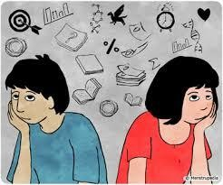
Advocate
Attachment
Care package
Clinical Commissioning Groups (CCGs)
Development

Discrimination
Diversity
Empathy
Ethical
Fine Motor Skills
Growth
Holistic Approach
Milestone
Nature

Nurture
Risk Assessment
Safeguarding
Self-Concept
Self-Esteem

Task 2: Research Task
Choose a professional from the following:
- Midwife
- Paramedic
- Paediatric nurse
- Nutritionist
- Physiotherapist
You could choose your own idea from health and social care roles if you prefer. Create a fact file for your chosen job role
You could include:
- A day in the life of……
- General roles and responsibilities
- Routes into the role/ qualifications required
- Skills & qualities
- Average pay

- Where they work
- Who they work with
And anything else you think may be suitable

Part 2: On ‘The front line’
Answer these questions:
- What does it mean when people talk about being ‘on the front line’?
- What does it mean when people talk about the situation as a pandemic? Now complete this table using research to help you
Job Role | Definition | Roles and Responsibilities | How do they respond in a pandemic?
District Nurse
Auxiliary Nurse
Palliative Care
Phlebotomist
Domiciliary Carer
Adult Social Worker

FINAL TASK- Health and Social Care in the Media
It is important to make the public realise about the issues which are prevailing in society relating to health and social care. One way in which public awareness is raised about health and social care in general and issues that exist within the health and social care sector is through the media.
Your task is to pick…
  - x2 Films
  - x1 Book
  - x2 Documentaries
You will then need to have a go at writing an essay with the following title:

‘Discuss the portrayal of Health and Social Care within the media’

You must watch/read the some of the examples given (in the remainder of this booklet) and create notes to help with your essay. Consider the following:
- What issues, if any, are being raised in the stimulus?
- How does the stimulus present H&SC?
Is the stimulus informative/helpful and why?
- Are there any quotes/scenes etc that stand out to you and why?
- How effective is the stimulus in raising public awareness about H&SC/Issues?
This list is NOT exhaustive there may be other questions/ideas you wish to consider as you watch or read.
Documentary Suggestions:
