Sixth Form A Level Psychology Transition Booklet

Name:

Welcome to Psychology at Morecambe Bay Academy

This Transition work is designed to help you to bridge the gap between your GCSE studies and AS/A Level.

Why do Transition work?
Preparation is crucial for studying A levels. A levels require you to be an independent learner. Although you have fewer subjects, A levels require different study skills and the volume of work is greater due to the increased demand of depth and detail. The exercises in this booklet will ensure that you are ready for the exciting challenges of becoming an A level student in September. It may be necessary to complete some of the tasks on separate sheets of paper. You have the choice of either typing or handwriting your responses. Each subject will be slightly different, but they will all require you to use the skills you will need for A level: independent enquiry; evidence of reading around the subject and enthusiasm and interest.

Is Transition work assessed?
Yes. In September, your subject teacher will ask you for your Transition work and it will be reviewed. Teachers will be able to diagnose your strengths and weaknesses and begin to support and challenge you in a more targeted way.

You must bring all the work with you to your first Year 12 Psychology lesson in September.

Your A Level Psychology will cover the following units YEAR 1

Paper 1: Introductory topics in Psychology:
- Social Psychology
- Cognitive Psychology
- Attachment

Paper 2: Psychology in Context
- Approaches and Biopsychology
- Psychopathology
- Research Methods YEAR 2

Paper 1: Introductory topics in Psychology:
- Social Psychology
- Cognitive Psychology
- Attachment
- Psychopathology

Paper 2: Psychology in Context
- Approaches
- Biopsychology
- Research Methods

Paper 3: Issues and Options in Psychology
- Issues and Debates
- Gender
- Forensic Psychology

Year 11 to Year 12 Psychology AS/A-Level Section: Examinations
You will sit three examination papers at the end of year 13:
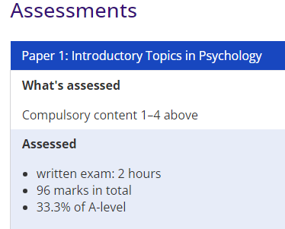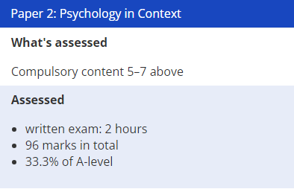

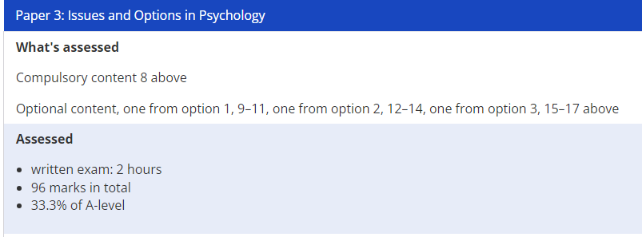

To complete this module of work:

- Section A contains examination questions which assess your comprehension, reading, attention and applied skills
- Section B contains research methods questions - these are mathematical skills that you should have developed from the GCSE years
- Section C contains an essay topic on a very famous study. This essay assesses your comprehension of the study as well as your critical thinking.

PSYCHOLOGY RESOURCES
Films & Documentaries:

Psychopathology
  - BBC Explorations, Primal Fear (https://www.youtube.com/watch?v=BzNSYw7xwpU)
  - Stephen Fry - The Secret Life Of The Manic Depressive
  - (https://www.youtube.com/watch?v=uj8hqXd7N_A)
  - BBC 3: Extreme OCD camp (https://www.youtube.com/watch?v=zAXjq28Wpyk)

Social Psychology
  - BBC Radio 4: Solomon Asch- Conformity: (http://www.bbc.co.uk/programmes/p00f8mzr)
  - Experimenter (2015): (http://www.imdb.com/title/tt3726704/)
  - ABC Channel: Milgram Experiment remake (https://www.youtube.com/watch?v=JnYUl6wlBF4&list=PL7B12D4D99E4FCC8B)
  - The Stanford Prison Experiment (2015): (http://www.imdb.com/title/tt0420293/)
  - BBC Radio 4 : The Stanford Prison Experiment: (http://www.bbc.co.uk/programmes/b008crhv)
  - BBC Radio 4: Julian Rotter and Locus of Control: (http://www.bbc.co.uk/programmes/b01gf5sr)

Cognitive Psychology
  - A series of videos on Working Memory Model: (http://gocognitive.net/interviews/alan-baddeley-working-memory)
  - The fiction of memory (https://www.youtube.com/watch?v=PB2OegI6wvI)
  - BBC iWonder: Would you be a reliable eyewitness? (http://www.bbc.co.uk/guides/zcc6sg8)

Attachment
  - Introduction to Attachment Theory (https://www.youtube.com/watch?v=zcnIo0NZrcw)
  - BBC Radio 4: Harlow’s Monkeys: (http://www.bbc.co.uk/programmes/b00ly7lp)
  - Ainsworth and Attachment (https://www.youtube.com/watch?v=4HHTohtXEq8)

Year 11 to Year 12 Psychology AS/A-Level Section A: 1. Biopsychology
Watch the following video on the nervous system: https://www.tutor2u.net/psychology/reference/biopsychology-nervous-system and indicate whether the following sentences are True (T) or False (F) (10 marks).

The nervous system is divided into the Peripheral nervous system (PNS) and the Central nervous system (CNS)
The CNS included only the brain
The CNS is responsible for higher-order thinking and reflex actions
The PNS is divided into Sympathetic and Parasympathetic
The Somatic nervous system (SNS) directs muscles and receiving/ transmitting messages from the senses
The Sympathetic nervous system is part of the Autonomic nervous system (ANS)
The Parasympathetic system is responsible for homeostasis
The Sympathetic system is used when quick action is required
The ANS has both motor and sensory pathways
The Sympathetic system is also called ‘Fight or Flight response’
The SNS is divided into Sympathetic and Parasympathetic
The temporal lobe is responsible for visual information
Score: /12

Section A: 2. Approaches

Social learning theory is one of the approaches which is used to explain behaviour. According to this theory, we learn a specific behaviour by observing other people in our environment. The following picture illustrates the main four mediating processes that take place when people observe others and imitate their behaviours.
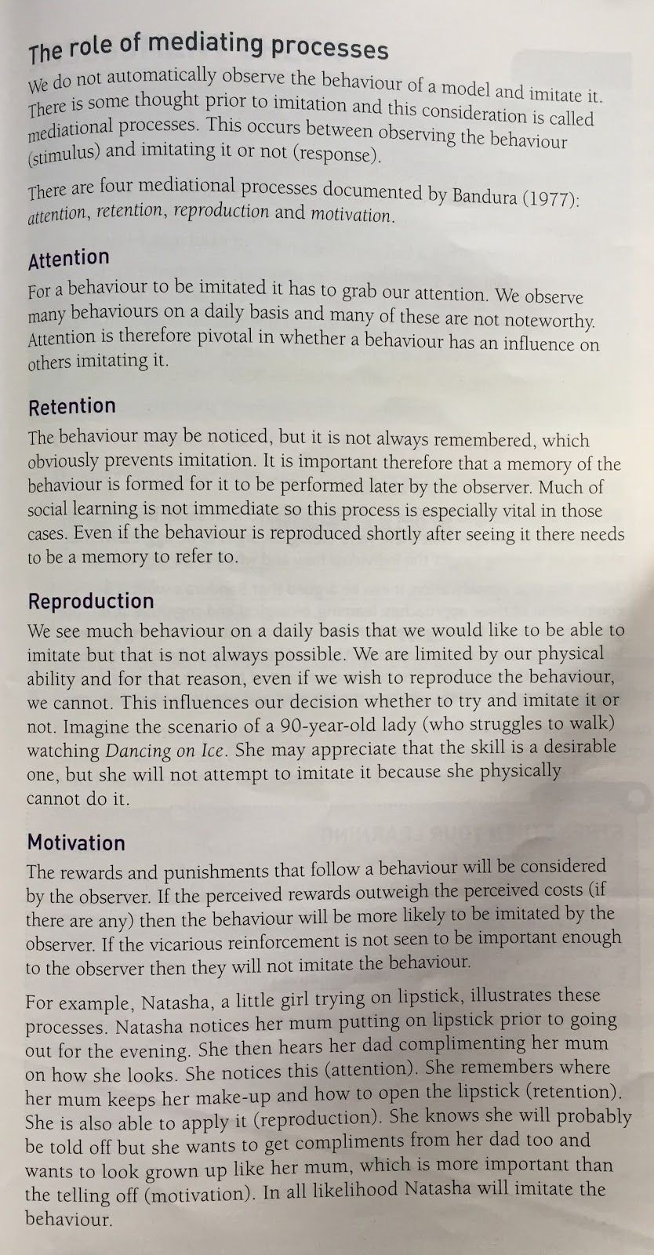
Question 1: Outline the mediating processes in Social Learning Theory (4 marks; one mark for each of the four concepts).

Question 2: With reference to mediating processes illustrated above, explain why Jerry’s mum found Jerry cleaning out the hamster cage (4 marks; one mark for each of the four concepts).

Jerry watches as his brother James is given sweets for cleaning their pet hamster’s cage. The next day, Jerry’s mum finds Jerry cleaning out the hamster cage.

Score: /8 Total score in Section A /20

Section B: Research Methods Questions

A psychologist wanted to find out whether males or females have better mathematical skills. 20 students, 10 boys and 10 girls, from a Sixth Form college were selected to take part in the study. The psychologist gave a mathematical test to the students. The maximum score that a student could take on the test was 20. The results of the study are mentioned in the Table below.
 | The scores boys and girls got on the test
Boys | 12, 13, 12, 20, 10, 20, 17, 19, 10, 12
Girls | 15, 16, 8, 11, 11, 10, 5, 12, 8, 7

- Find the mode for males and females. (2 marks)

- Calculate the median score for males and females. Show your workings. (3 marks)

- Calculate the mean score for males and females. Show your workings. (3 marks)

- Calculate the percentage of boys who scored <15? Show your workings. (4marks)

- Calculate the fraction of girls who scored 8? Write the fraction in lowest terms. Show your workings. (4 marks)

- Calculate the ratio of boys : girls who scored 15 or more? Write the ratio in lowest terms. Show your workings. (4 marks)

Total score in Section B: /20

Section C: Essay

Watch the following documentaries and write an essay of 300-400 words which summarises Milgram’s experiment.
https://www.youtube.com/watch?v=8bbVFeTIIg8
https://www.dailymotion.com/video/x4xk2sy

Refer to the following points in your answer:
  - Who were the participants of this study? How were they selected?
  - What were the roles assigned to the participants?
  - What was the task of the ‘teacher’? What was the task of the ‘learner’?
  - What was the shock generator?
  - What was the real aim of the study?
  - What were the predictions of the results before the study? What were the actual results
of the study?

Critical thinking:

  - Why was the ‘teacher’ deceived?
  - Why did the ‘student’ mentioned his medical condition?
  - Why did the ‘teacher’ receive a sample shock?
  - Why did the experimenter prompt the ‘teacher’ by saying “The experiment requires you to continue, Teacher”?
  - How did different ‘teachers’ react when they were delivering the shocks? Did they all obey the experimenter’s orders? If not, why?
  - When the ‘teacher’ asked the experimenter who was responsible if something happened to the ‘learner’ why did the experimenter say “The responsibility is mine”?
  - How did the Milgram protect the welfare and dignity of the participants?

Total score in Section C: /20

Final score /60

Milgram’s Experiment

