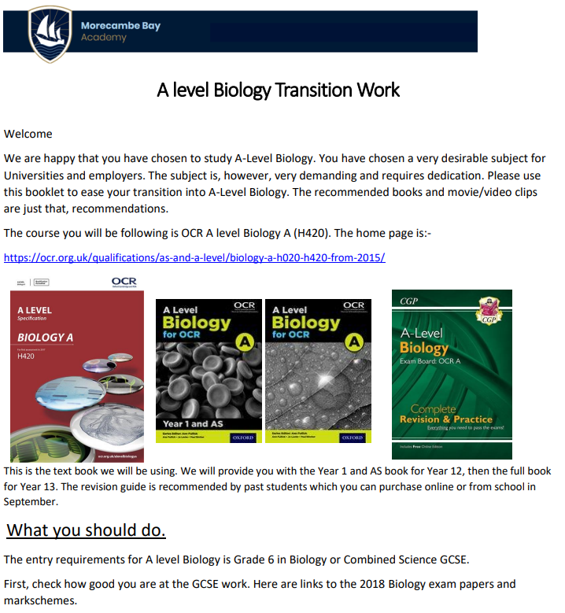
The entry requirements for A level Biology is Grade 6 in Biology or Combined Science GCSE. First, check how good you are at the GCSE work. Here are links to the 2018 Biology exam papers and markschemes.
Paper 1 Higher https: //www.ocr.org.uk/Images/234579-unit-j247-03-biology-higher-tier-paper-3-sample-assessment-material.pdf
Paper 2 Higher https://www.ocr.org.uk/Images/234580-unit-j247-04-biology-higher-tier-paper-4-sample-assessment-material.pdf

Contents for transition work in A Level Biology
The material contained within the rest of the Biology pack is extended GCSE level to help prepare for the A Level Biology course. It is recommended that you aim to complete as much as possible to help you in Yr 12.
- Get Inspired- Read some books and watch some films!
- Recap and Extend- Complete the activities and the questions. Use the suggested websites and the basic recap material to help you on the following topics:
1. Cells and cell division
2. Biological molecules
3. Exchange and Transport
4. Energy
5. DNA and the genetic code
6. Scientific Skills
7. Maths skills and answers
8. Challenge- Taking it further

Get Inspired! Find out about Biology

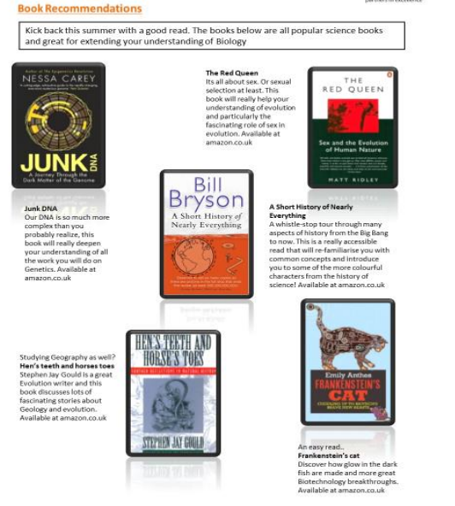

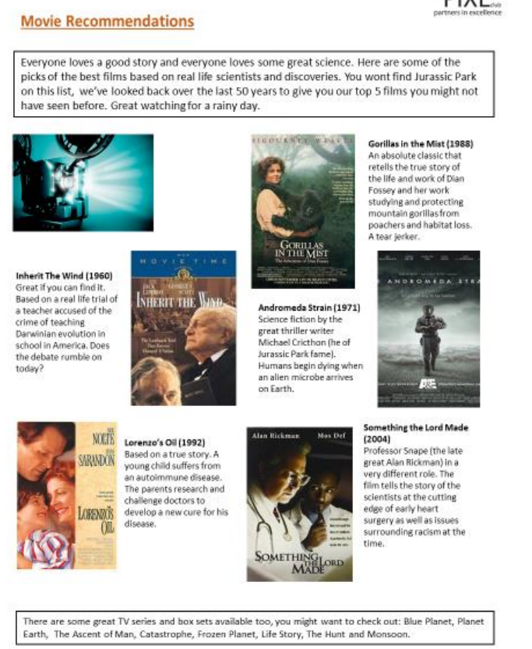

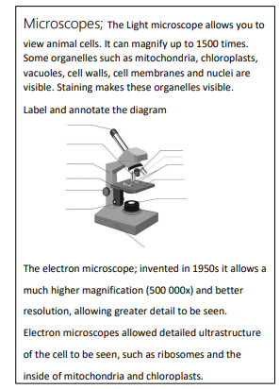
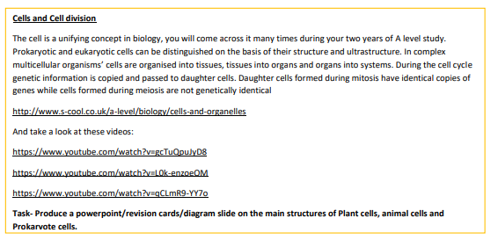
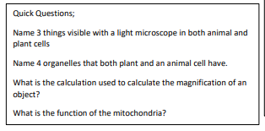
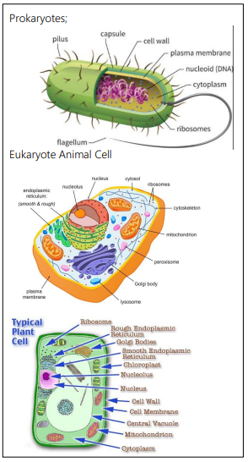

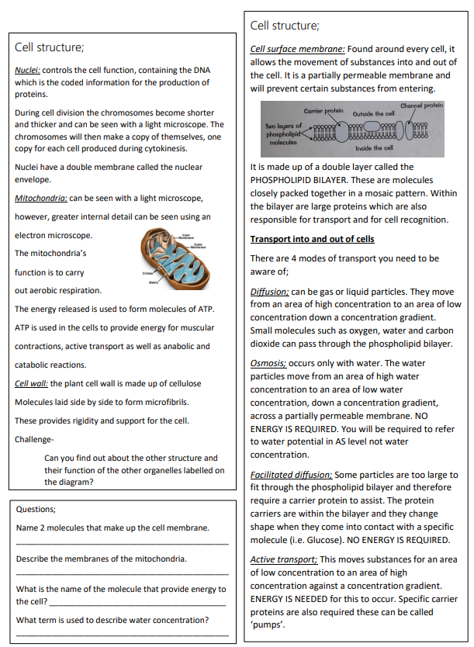
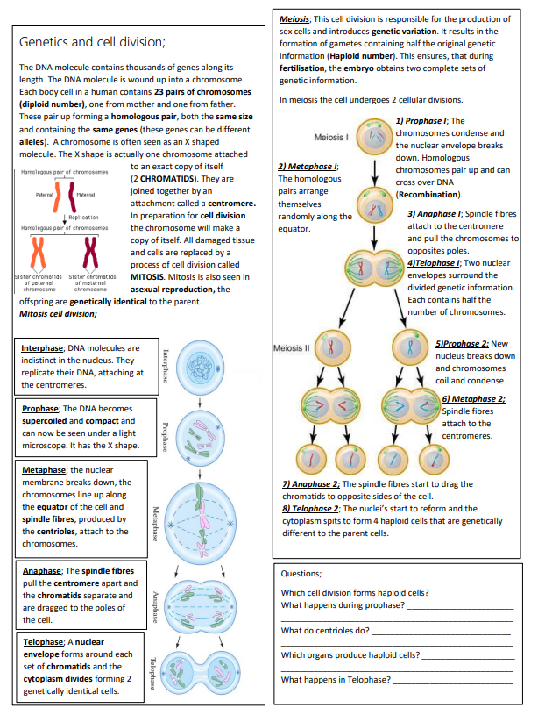
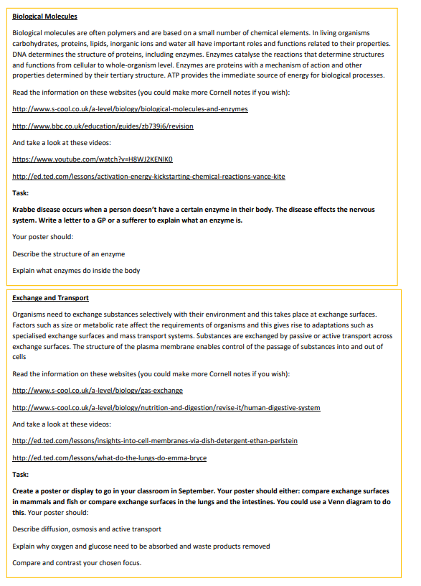
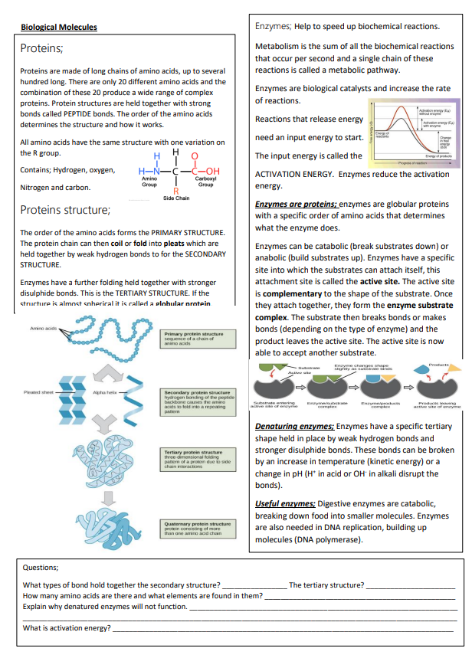
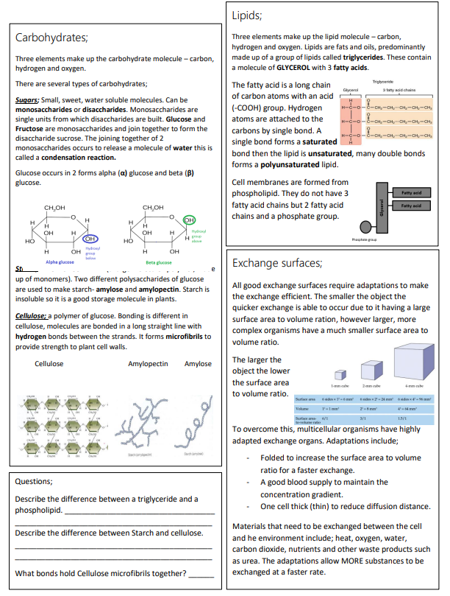

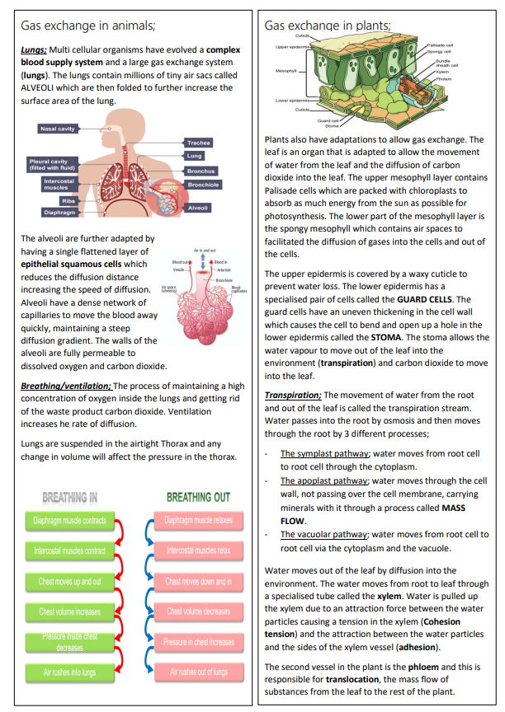
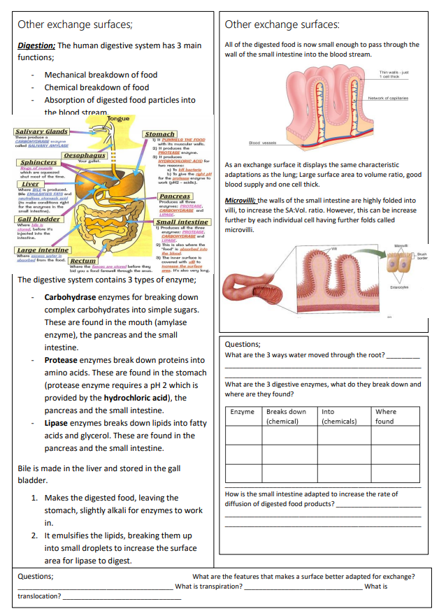
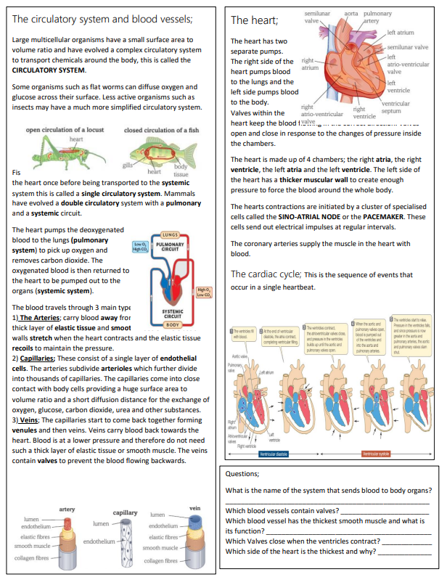

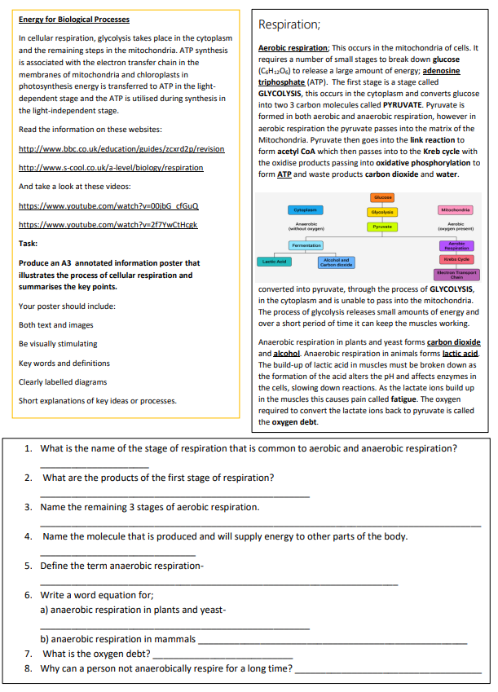
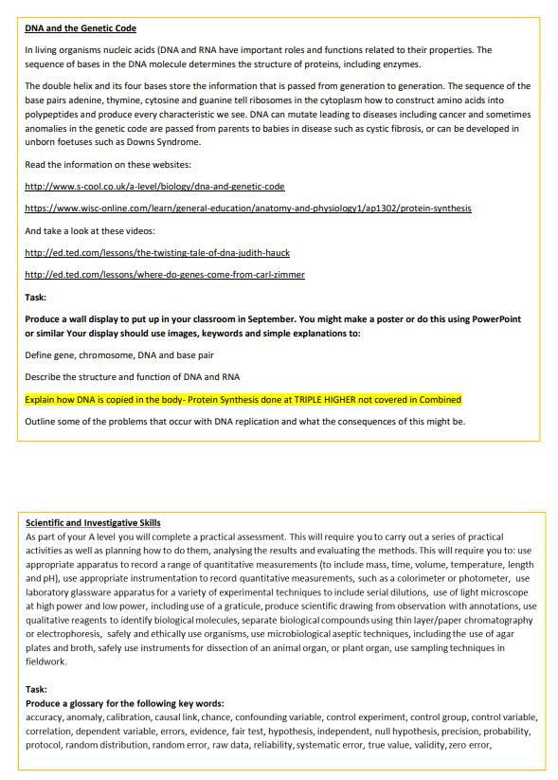
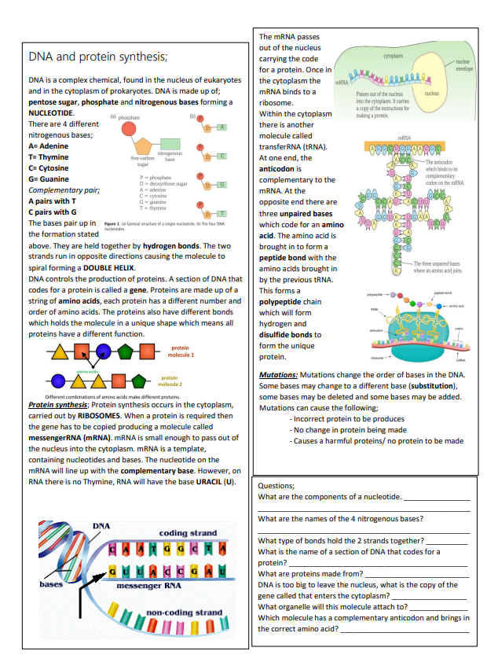
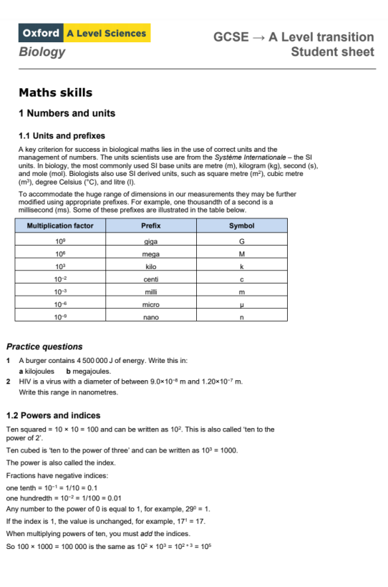
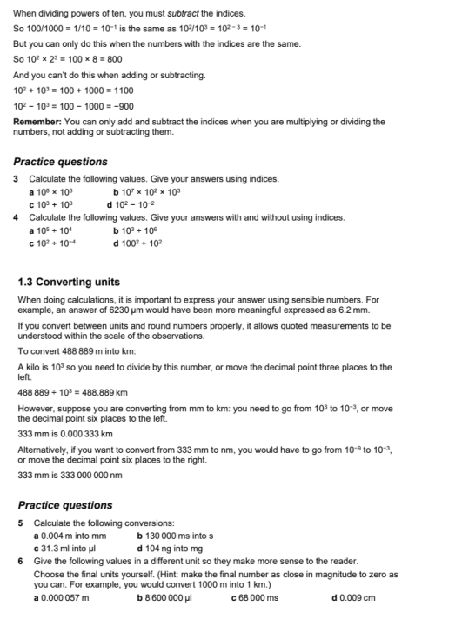

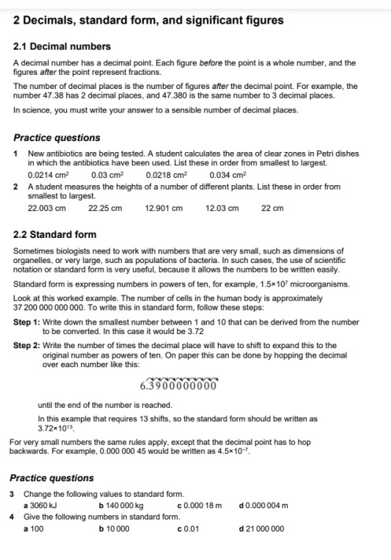

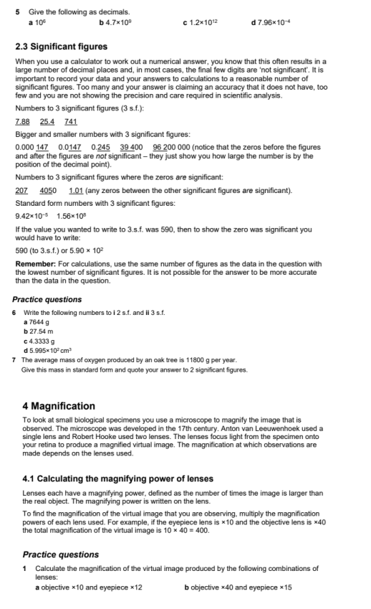
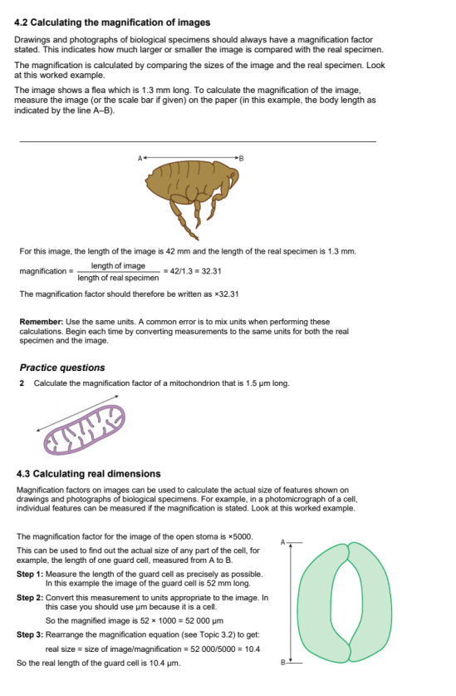
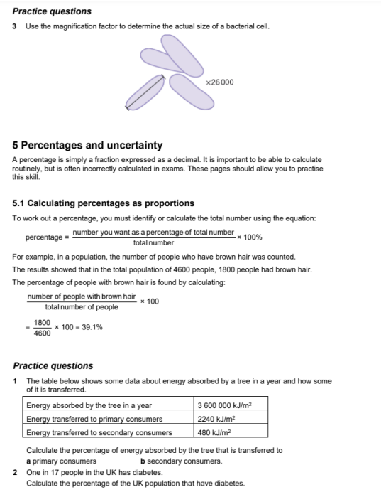
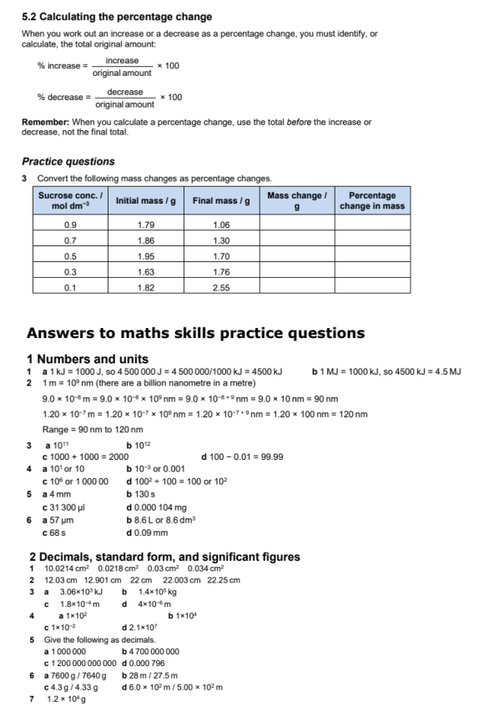
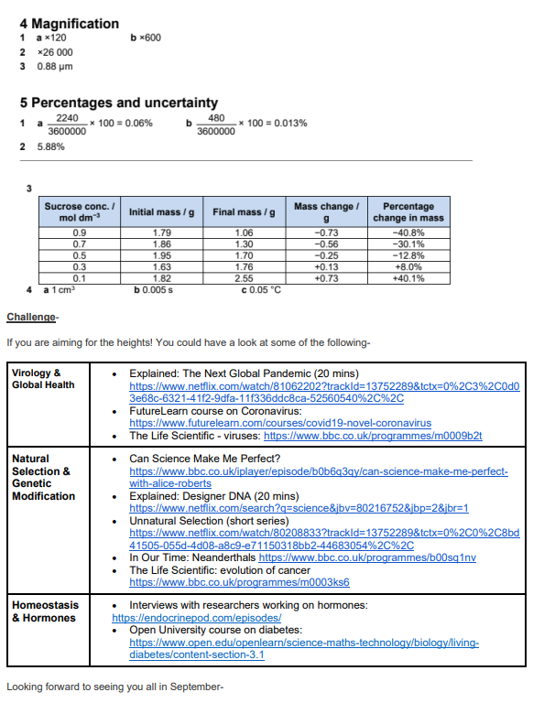
Mrs Bradley & Miss Miller

