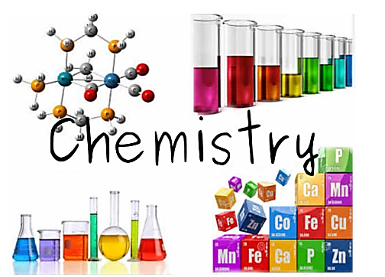

Memorising the following basic facts will really help with your transition to A level chemistry.
Learn:
- The formulae of common substances
- The formulae of common lab acids
- The general reactions of acids & ionic equation for neutralisation
- The reactivity Series of metals
- The formulae of common ions
- The moles equations

Working independently through the attached transition tasks will also help.

Formulae of common compounds and diatomic elements

substance | Physical state at room temperature | Structure/bonding present | formula
oxygen | gas | simple covalent molecular | O₂
hydrogen |  |  | H₂
nitrogen |  |  | N₂
fluorine |  |  | F₂
chlorine |  |  | Cl₂
bromine | liquid |  | Br₂
iodine | solid |  | I₂
water | liquid |  | H₂0
carbon dioxide | gas |  | CO₂
carbon monoxide |  |  | CO
sulfur dioxide |  |  | SO₂
nitrogen monoxide |  |  | NO
nitrogen dioxide |  |  | NO₂
methane |  |  | CH₄
ammonia |  |  | NH₃
hydrogen chloride |  |  | HCl
silicon(IV)oxide | solid | giant covalent | SiO₂
sodium chloride | solid | giant ionic | NaCl
sodium hydroxide |  |  | NaOH
calcium carbonate |  |  | CaCO₃
copper(II)oxide |  |  | CuO
copper(II)sulfate |  |  | CuSO₄
ammonium nitrate |  |  | NH₄NO₃

State symbols
solid (s) liquid (l) gas (g) aqueous solution (aq)

Formulae of common lab acids
acid | formula | ions produced in solution |  | name of salt produced
hydrochloric acid | HCl(aq) | H⁺ | Cl⁻ | chloride
nitric acid | HNO₃(aq) | H⁺ | NO₃⁻ | nitrate
sulfuric acid | H₂SO₄(aq) | H⁺ | SO₄²⁻ | sulfate
ethanoic acid | CH₃COOH(aq) | H⁺ | CH₃COO⁻ | ethanoate

General reactions of acids

acid + metal salt + hydrogen

acid + base salt + water

acid + alkali salt + water

acid + carbonate salt + water + carbon dioxide

A base is a metal oxide or metal hydroxide; an alkali is a soluble base
A salt is produced when the H⁺ ions in an acid are replaced by metal ions or ammonium ions

Ionic equation for neutralisation

H⁺(aq) + OH⁻(aq) H₂O(l)
Reactivity Series of Metals

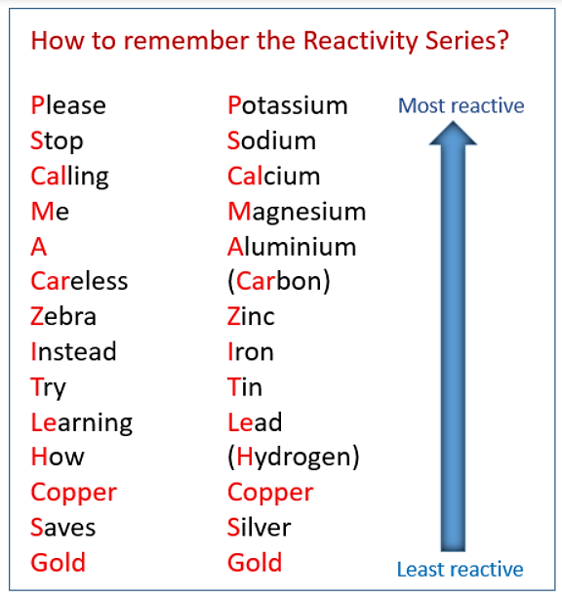

Formula of common ions

cations |  | anions
lithium | Li⁺ | fluoride | F⁻
sodium | Na⁺ | chloride | Cl⁻
potassium | K⁺ | bromide | Br⁻
magnesium | Mg²⁺ | iodide | I⁻
calcium | Ca²⁺ | oxide | O²⁻
barium | Ba²⁺ | sulfide | S²⁻
aluminium | Al³⁺ | nitride | N³⁻
copper(II) | Cu²⁺ | hydroxide | OH⁻
Iron(II) | Fe²⁺ | nitrate | NO₃⁻
Iron(III) | Fe³⁺ | sulfate | SO₄²⁻
zinc | Zn²⁺ | carbonate | CO₃²⁻
silver | Ag⁺ | hydrogencarbonate | HCO₃⁻
ammonium | NH₄⁺

Moles Equations
n is the number of moles present in:
- a given mass of substance
n = $\frac{m}{M}$
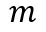 is the mass in grams, 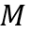 is the molar mass (Mr or Ar)

- a given volume of solution
n = c x $\frac{V}{1000}$
c is the concentration in mol dm⁻³, V is the volume in cm³

- a given volume of gas
- n = $\frac{V}{24}$ or b) n = $\frac{V}{24000}$
V is the volume of gas in a) dm³ or b) cm³
Seven skills to get an A* in chemistry
- Use the periodic table as a starting point for thinking
Consult PT with most questions using general understanding of trends, understanding of fundamental particles
- Visualise physical and chemical processes
eg visualise regions of high and low electron density, molecular processes like Brownian motion (M–B distribution), solvation of ions, hydrogen bonds
- Switch between different representations
of substances eg names, different formulae (skeletal, structural etc), models, diagrams and apparatus
- Manipulate mathematical equations
Rearranging equations successfully, taking account of the magnitudes of the numbers within (eg need to factor into equation change of units for cm³/dm³ or kJ/J), substituting correct numbers
- Relate observable phenomena to underlying concepts
eg colour changes, melting points, distillation/recrystallisation procedure
- Chemical common sense
General awareness of physical forms of chemical substances eg colour, state, solubility and general idea of what reacts together
- Write explanations logically without repetition or contradiction
Focus in on the explanation needed, present answers clearly in a logical order, don’t write the same explanation twice in different words or include contradictory explanations
Bullseye exercise
Below is a bullseye diagram. For each of the seven skills decide how skilled you are and shade in the appropriate number of segments of the bullseye.
2. Visualise physical and chemical processes

7. Write explanations logically without repetition or contradiction

3. Switch between different representations
6. ‘Chemical common sense’
5. Relate observable phenomena to underlying concepts

4. Manipulate mathematical equations
- Use the periodic table as a starting point for thinking

Starters for 10 – Transition skills
0.1.1 Balancing equations

Balance the equations below.

1. …..C + …..O₂ |  | …..CO
2. …..Ba + …..H₂O |  | …..Ba(OH)₂ + …..H₂
3. …..C₂H₆ + …..O₂ |  | …..CO₂ + …..H₂O
4. …..HCl + …..Mg(OH)₂ |  | …..MgCl₂ + H₂O
5. …..N₂ + …..O₂ |  | …..NO
6. …..Fe₂O₃ + …..C |  | …..Fe + …..CO₂
7. …..CH₃CH₂OH + …..[O] |  | …..CH₃COOH + …..H₂O
8. …..HNO₃ + …..CuO |  | …..Cu(NO₃)₂ + H₂O
9. …..Al³⁺ + …..e– |  | …..Al
10. …..[Fe(H₂O)₆]³⁺ + …..CO₃^{2–} |  | …..Fe(OH)₃(H₂O)₃ + …..CO₂ + …..H₂O

(10 marks)

Starters for 10 – Transition skills
0.1.2 Constructing ionic formulae

- For each of the following ionic salts, determine the cation and anion present and use these to construct the formula of the salt. (5 marks)

- Magnesium oxide

- Sodium sulfate

- Calcium hydroxide

- Aluminium oxide

- Copper(I) oxide

2. When an acid is added to water it dissociates to form H⁺ ions (which make it acidic) and an anion. These acidic hydrogen atoms can be used to determine the charge on the anion.
Deduce the charge on the anions in the following acids. The acidic H atoms, H⁺, have been underlined for you. (5 marks)

- H₂SO₃

- HNO₃

- H₃PO₄

- HCOOH

- H₂CO₃

Starters for 10 – Transition skills
0.1.3 Writing equations from text
The following questions contain a written description of a reaction. In some cases the products may be missing as you will be expected to predict the product using your prior knowledge. For more advanced equations you may be given some of the formulae you need. For each one, write a balanced symbol equation for the process. (10 marks)
1. The reaction between silicon and nitrogen to form silicon nitride Si₃N₄.

2. The neutralisation of sulfuric acid with sodium hydroxide.

3. The preparation of boron trichloride from its elements.

4. The reaction of nitrogen and oxygen to form nitrogen monoxide.

5. The combustion of ethanol (C₂H₅OH) to form carbon dioxide and water only.

6. The formation of silicon tetrachloride (SiCl₄) from SiO₂ using chlorine gas and carbon.

7. The extraction of iron from iron(III) oxide (Fe₂O₃) using carbon monoxide.

8. The complete combustion of methane.

9. The formation of one molecule of ClF₃ from chlorine and fluorine molecules.

10. The reaction of nitrogen dioxide with water and oxygen to form nitric acid.

Starters for 10 – Transition skills
0.2.1 Rearranging equations

1. The amount of substance in moles (n) in a solution can be calculated when the concentration given in mol/dm³ (c) and volume (v) in cm³ are known by using the equation:
$$\text{n = }\frac{\text{cv}}{\text{1000}}$$
- Rearrange this equation making c the subject of the equation.(1 mark)

- Rearrange this equation making v the subject of the equation. (1 mark)

2. The density of a substance can be calculated from its mass (m) and volume (v) using the equation:
$$\text{d = }\frac{\text{m}}{\text{v}}$$
- Rearrange this equation so that the mass of a substance can be calculated given its density and volume. (1 mark)

Chemists most commonly work with masses expressed in grams and volumes in cm³. However, the SI unit for density is kg/m³.
- Write an expression for the calculation of density in the SI unit of kg/m³ when the mass (m) of the substance is given in g and the volume (v) of the substance is given in cm³. (2 marks)

3. The de Broglie relationship relates the wavelength of a moving particle (λ) with its momentum (p) through Planck’s constant (h):
$$\text{ λ} \text{= }\frac{\text{ h}}{\text{p}}$$
- Rearrange this equation to make momentum (p) the subject of the formula. (1 mark)

Momentum can be calculated from mass and velocity using the following equation.
$$\text{p =mv}$$
- Using this equation and the de Broglie relationship, deduce the equation for the velocity of the particle. (2 marks)

4. The kinetic energy (KE) of a particle in a time of flight mass spectrometer can be calculated using the following equation.
$$\text{KE =}\frac{\text{1}}{\text{2}}\text{m}{\text{v}}^{\text{2}}$$
Rearrange this equation to make v the subject of the equation. (2 marks)

Starters for 10 – Transition skills
0.2.4 Expressing large and small numbers

Standard form and scientific form
Large and small numbers are often expressed using powers of ten to show their magnitude. This saves us from writing lots of zeros, expresses the numbers more concisely and helps us to compare them.
In standard form a number is expressed as;
a × 10^{n}
where a is a number between 1 and 10 and n is an integer.
Eg, 160 000 would be expressed as 1.6 × 10⁵
Sometimes scientists want to express numbers using the same power of ten. This is especially useful when putting results onto a graph axis. This isn’t true standard form as the number could be smaller than 1 or larger than 10. This is more correctly called scientific form.
Eg, 0.9 × 10^{–2}, 2.6 × 10^{–2}, 25.1 × 10^{–2} and 101.6 × 10^{–2} are all in the same scientific form.

1. Express the following numbers using standard form.
- 1 060 000

- 0.001 06

- 222.2

(3 marks)

2. The following numbers were obtained in rate experiments and the students would like to express them all on the same graph axes. Adjust the numbers to a suitable scientific form.
0.1000 0.0943 0.03984 0.00163

(3 marks)

3. Calculate the following without using a calculator. Express all values in standard form.
- $\frac{{10}^{9}}{{10}^{5}}$

- $\frac{{10}^{7}}{{10}^{-7}}$

- $\frac{{1.2 × 10}^{6}}{2.4 {× 10}^{17}}$

- ${(2.0 × 10}^{7}) × {(1.2 × 10}^{-5 })$

(4 marks)
Starters for 10 – Transition skills
0.2.5 Significant figures, decimal places and rounding

For each of the numbers in questions 1–6, state the number of significant figures and the number of decimal places.
 |  | Significant figures | Decimal places
1 | 3.131 88
2 | 1000
3 | 0.000 65
4 | 1006
5 | 560.0
6 | 0.000 480
(6 marks)
7. Round the following numbers to (i) 3 significant figures and (ii) 2 decimal places.
- 0.075 84

- 231.456
(4 marks)

Starters for 10 – Transition skills
0.3.1 Laboratory equipment

Practical work is a key aspect in the work of a chemist.
To help you plan effective practical work it is important that you are familiar with the common laboratory equipment available to you.
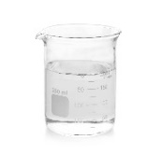
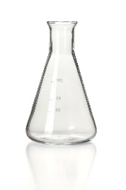
1. For each of the pieces of glassware shown in the images below, state their name and give a possible volume(s).
a. Name: b. Name:

Possible volume(s): Possible volume(s):

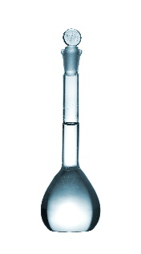
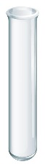
c. Name: d. Name:

Possible volume(s): Possible volume(s):

e. Name: f. Name:

Possible volume(s): Possible volume(s):

(6 marks)

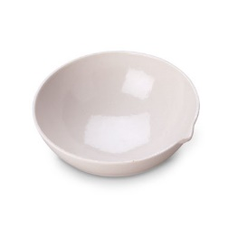
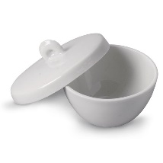
2. Name the common laboratory equipment in the images below. (4 marks)
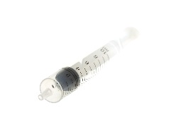
a. b. c.

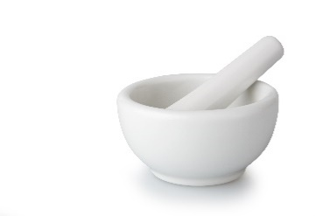
…
d. …………………………………………………………………………..

Starters for 10 – Transition skills
0.3.2 Recording results
1. A student is looking at endothermic processes. He adds 2.0 g of ammonium nitrate to 50 cm³ of water and measures the temperature change. He repeats the experiment three times.
His results are shown in the table below.
 | Temperature at start | Temperature at end | Temperature change
Run 1 | 21.0 | –1.1 | 22.1
Run 2 | 20 | –2 | 22
Run 3 | 20.2 | 2 | 18.2
Mean |  |  | 22.05

Annotate the table to suggest five ways in which the table layout and the recording and analysis of his results could be improved.(5 marks)

2. For each of the experiments described below, design a table to record the results.
Experiment 1: Simon is investigating mass changes during chemical reactions. He investigates the change in mass when magnesium ribbon is oxidised to form magnesium oxide:
magnesium + oxygen → magnesium oxide
He records the mass of an empty crucible. He places a 10 cm strip of magnesium ribbon in the crucible and records the new mass of the crucible. He heats the crucible strongly until all the magnesium ribbon has reacted to form magnesium oxide. He allows the crucible to cool before recording the mass of the crucible and magnesium oxide.

Experiment 2: Nadiya is investigating how the rate of a reaction is affected by concentration. She investigates the reaction between magnesium ribbon and hydrochloric acid.
magnesium + hydrochloric acid → magnesium chloride + hydrogen
She places 25 cm³ of hydrochloric acid with a concentration of 0.5 mol dm^{–3} into a conical flask and fits a gas syringe. She adds a 3.0 cm strip of magnesium ribbon and measures the volume of hydrogen gas produced every 20 s for 3 minutes.
She repeats the experiment with hydrochloric acid with concentrations of 1.0 mol dm^{–3} and then 1.5 mol dm^{–3}.
(5 marks)

Starters for 10 – Transition skills
0.3.3 Drawing scatter graphs

When you want to find a correlation between two variables it is helpful to draw a scatter graph.
Key points to remember when drawing scatter graphs include:
- The independent variable (the variable that is changed) goes on the x-axis and the dependent variable (the variable you measured) goes on the y-axis.
- The plotted points must cover more than half the graph paper.
- The axes scales don’t need to start at zero.
- A straight line or smooth curve of best fit is drawn through the points to show any correlation.

Karina is investigating the relationship between the volume of a gas and its temperature. She injects 0.2 cm³ of liquid pentane (b.p. 36.1 °C) into a gas syringe submerged in a water bath at 40 °C. After 5 minutes she measures the volume of gas in the syringe. She repeats the experiment three times with the water bath at 40 °C.
She then repeats the experiment for temperatures of 50, 60, 70 and 80 °C.
Her results are shown in the table below:
Temperature / °C | Volume of gas / cm³
 | Run 1 | Run 2 | Run 3 | Mean
40 | 40.8 | 43.1 | 42.7 | 42.2
50 | 46.1 | 46.2 | 46.9 | 46.4
60 | 54.7 | 48.1 | 48.3 | 48.2
70 | 49.1 | 49.6 | 49.5 | 49.4
80 | 51.0 | 47.3 | 51.0 | 51.0

1. Plot a scatter graph of the volume of the gas against the temperature.(6 marks)
2. Add error bars to show the range of readings used to calculate the mean volume of the gas at each temperature.(2 marks)
3. Draw in a line of best fit. (1 mark)
4. Describe the correlation observed. (1 mark)

Starters for 10
Transition skills answers

0.1 Basic chemistry competencies
0.1.1. Balancing equations
Accept multiples or appropriate fractions, 1 mark each.
1. 2C + …..O₂ |  | 2CO
2. …..Ba + 2H₂O |  | …..Ba(OH)₂ + …..H₂
3. …..C₂H₆ + 3.5O₂ |  | 2CO₂ + 3H₂O
4. 2HCl + …..Mg(OH)₂ |  | …..MgCl₂ + 2H₂O
5. …..N₂ + …..O₂ |  | 2NO
6. 2Fe₂O₃ + …3C |  | 4Fe + 3CO₂
7. …..CH₃CH₂OH + 2[O] |  | …..CH₃COOH + …..H₂O
8. 2HNO₃ + …..CuO |  | …..Cu(NO₃)₂ + H₂O
9. …..Al³⁺ + 3e– |  | …..Al
10. 2Fe(H₂O)₆³⁺ + 3CO₃^{2–} |  | 2Fe(OH)₃(H₂O)₃ + 3CO₂ + 3H₂O

0.1.2. Constructing ionic formulae
1.
a. Mg²⁺ O^{2–} = MgO (1 mark)
b. Na⁺ SO₄^{2–} = Na₂SO₄ (1 mark)
c. Ca²⁺ OH– = Ca(OH)₂ (1 mark)
d. Al³⁺ O^{2–} = Al₂O₃ (1 mark)
e. Cu⁺ O^{2–} = Cu₂O (1 mark)

2.
a. SO₄^{2–} (1 mark)
b. NO₃– (1 mark)
c. PO₄^{3–} (1 mark)
d. HCOO– (1 mark)
e. CO₃^{2–} (1 mark)

0.1.3. Writing equations from text
1 mark each, accept multiples for all except question 9.
1. 3Si + 2N₂ |  | Si₃N₄
2. H₂SO₄ + 2NaOH |  | Na₂SO₄ + 2H₂O
3. B + ½ Cl₂ |  | BCl₃
4. N₂ + O₂ |  | 2NO
5. C₂H₅OH + 3O₂ |  | 2CO₂ + 3H₂O
6. SiO₂ + C + 2Cl₂ |  | SiCl₄ + CO₂
7. Fe₂O₃ + 3CO |  | 2Fe + 3CO₂
8. CH₄ + 2O₂ |  | CO₂ + 2H₂O
9. ½ Cl₂ + 1 ½ F₂ |  | ClF₃
10. 2NO₂ + H₂O + ½ O₂ |  | 2HNO₃

Starters for 10
Transition skills answers

0.2 Basic mathematical competencies
0.2.1. Rearranging equations
1.
a. $c =\frac{1000n}{v}$ (1 mark)
b. $v= \frac{1000n}{c}$ (1 mark)

2.
a. $m =d ×v$ (1 mark)
b. $d = \frac{{m x 10}^{-3}}{v {x 10}^{-6}}$ = $\frac{m}{v x {10}^{-3}}$
1 mark for both parts of the fraction correct, 1 mark for cancelling down the × 10^{–6} to × 10^{–3}. (2 marks)

3.
a. $p= \frac{h}{λ}$ (1 mark)
b. $v= \frac{h}{λm}$
1 mark for substitution of p = mv into the first equation and 1 mark for successful rearrangement.
(2 marks)
4.
$v =\sqrt{\frac{KE}{0.5m}}$ or $v= \sqrt{\frac{2KE}{m}}$
1 mark for first rearrangement moving 0.5 m underneath the KE, 1 mark for dealing with the v² by addition of the square root. (2 marks)
0.2.4. Expressing large and small numbers
1. a. 1.06 × 10⁶(1 mark)
b. 1.06 × 10^{–3}(1 mark)
c. 2.222 × 10²(1 mark)
2. 1 mark for sensible choice of × 10^{x} power, in this case × 10^{–2} or × 10^{–3} is most sensible. 0.5 marks for each number correctly converted.
3. a. 10⁴(1 mark)
b. 10¹⁴(1 mark)
c. 0.5 × 10^{–11} or 5 × 10^{–12}(1 mark)
d. 2.4 × 10²(1 mark)
0.2.5. Significant figures, decimal places and rounding
 |  | Significant figures | Decimal places
1 | 3.131 88 | 6 | 5
2 | 1000 | 1 | 0
3 | 0.000 65 | 2 | 5
4 | 1006 | 4 | 0
5 | 560.0 | 4 | 1
6 | 0.000 480 | 3 | 6
(0.5 mark for each correct answer)
7. a. i. 0.0758(1 mark)
ii. 0.08(1 mark)
b. i. 231(1 mark)
ii. 231.46(1 mark)

Starters for 10
Transition skills answers

0.3 Basic practical competencies
0.3.1. Laboratory equipment
1. For each part (a)–(e) give ½ mark for the correct name and ½ mark for one or more correct possible volumes depending on what is available in your laboratory.
a. conical flask
100 cm³ / 250 cm³
b. beaker
100 cm³ / 250 cm³
c. volumetric flask
100 cm³ / 200 cm³ / 250 cm³
d. test tube or boiling tube
10 cm³ or 25 cm³
e. burette
50 cm³
f. pipette
various sizes although 20 cm³ or 25 cm³ are the most common at school level

2. a. (gas) syringe(1 mark)
b. evaporating basin(1 mark)
c. crucible(1 mark)
d. pestle and mortar (the mortar is the bowl)(1 mark)

0.3.2. Recording results
1. Improvements:(1 mark for each improvement identified)
- Units for temperature should be included in the table headings.
- All results should be recorded to the same number of decimal places (the resolution of the thermometer used), in this case 1 d.p.
- The temperature changes are negative and so should be recorded as such, eg –22.1, or the heading should be changed to ‘Temperature decrease’ or similar.
- The temperature change for Run 3 is anomalous and so should be circled, or similar, to show this. It is correctly not included in the calculation of the mean.
- The mean temperature change should be stated to the same number of significant figures as the values from which it is calculated.

2. Experiment 1:(2 marks)
Mass / g
Crucible empty
Crucible + magnesium ribbon
Crucible + magnesium oxide

1 mark – Units given in table heading
1 mark – Clear description of item of which the mass is being recorded
Use teacher discretion to award marks for other suitable tables

Experiment 2: (3 marks)

Time / s | Volume of hydrogen gas produced / cm³
 | 0.5 mol dm^{–3} HCl(aq) | 1.0 mol dm^{–3} HCl(aq) | 1.5 mol dm^{–3} HCl(aq)
0
20
40
60
80
100
120
140
160
180

1 mark – Columns clearly labelled with units
1 mark – Dependent variable (volume of hydrogen gas) across columns
Independent variable (time) down rows
1 mark – Time starts at 0 and is in seconds throughout table (ie not 1 min 20 s)

0.3.3. Drawing scatter graphs
1. Graph plotted with marks allocated as follows:
- Temperature on the x-axis, volume on the y-axis.(1 mark)
- Suitable scales are chosen so that the plotted points cover more than half the graph paper (ie axes do not start at 0).(1 mark)
- Axes labelled with value and unit.1 mark)
- Points are plotted accurately with a neat pencil cross and within ±1 square.
All points plotted accurately 3 marks
4 points plotted accurately 2 marks
3 points plotted accurately 1 mark
2. Error bars are added to each plotted point (except 80 °C, 51.0 cm³)(1 mark)
Anomalous values circled in table not included in error bars(1 mark)
3. Suitable line of best fit drawn (1 mark)
4. As the temperature increases the volume of the gas increases (or suitable similar comparative statement)(1 mark)

