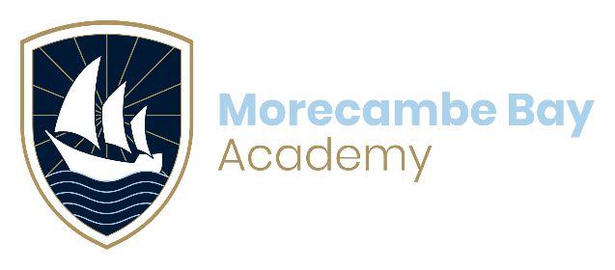

EXAMINATION RESULTS: SUMMER 2025

Candidate permission form Results collection

Results day(s):

**GCE** - Thursday 14 August 2025

**GCSE** - Thursday 21 August 2025

Results are usually collected from the Centre by the candidate on the relevant results day.

Uncollected results will be posted out at the end of results day by 1st class mail to the address held on our system1. If you require your results by either method below, please tick the relevant box and complete the required information.

|  |  |  |  |
| --- | --- | --- | --- |
| Candidate name |  | | |
| * Results should be sent to my email address ___ _________@_______ _____ * I give permission for my representative insert name of representative here_________   to collect results on my behalf. I confirm that my representative will provide photographic ID on collection | | | |
| Candidate signature |  | Date |  |

1 Any change of address should be notified through the official change in details process. The centre does not take any responsibility for results information sent out to addresses where this process has not been followed.

Completed forms should be returned to Reception or sent by email to: exams@morecambebayacademy.co.uk.